Scenario 2: EBS snapshot, create a volume out of EBS snapshot and attach it to an instance.
You want to take an EBS snapshot of a Windows Server so that in the future, you can bring up another server with the exact same configuration and data.
In this scenario, lets create a file in windows server before creating a snapshot and let’s validate after building another windows server using that volume. Let’s validate that file is there or not.
Step 1: login to server > under C drive create a file earilerwindowsserver-ebs.
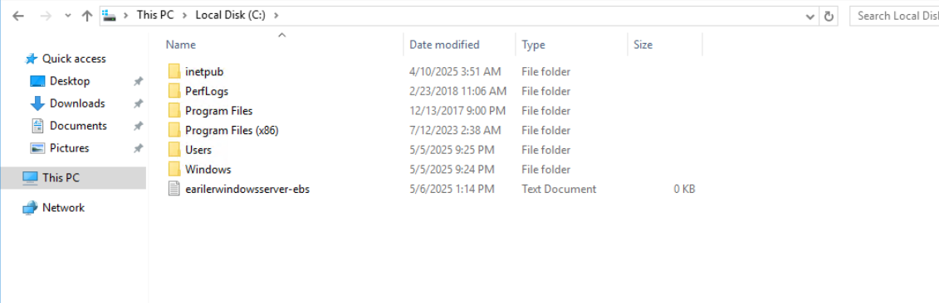

Step 2: Click on windows server and scroll to storage and click on the volume id. To create EBS snapshot.
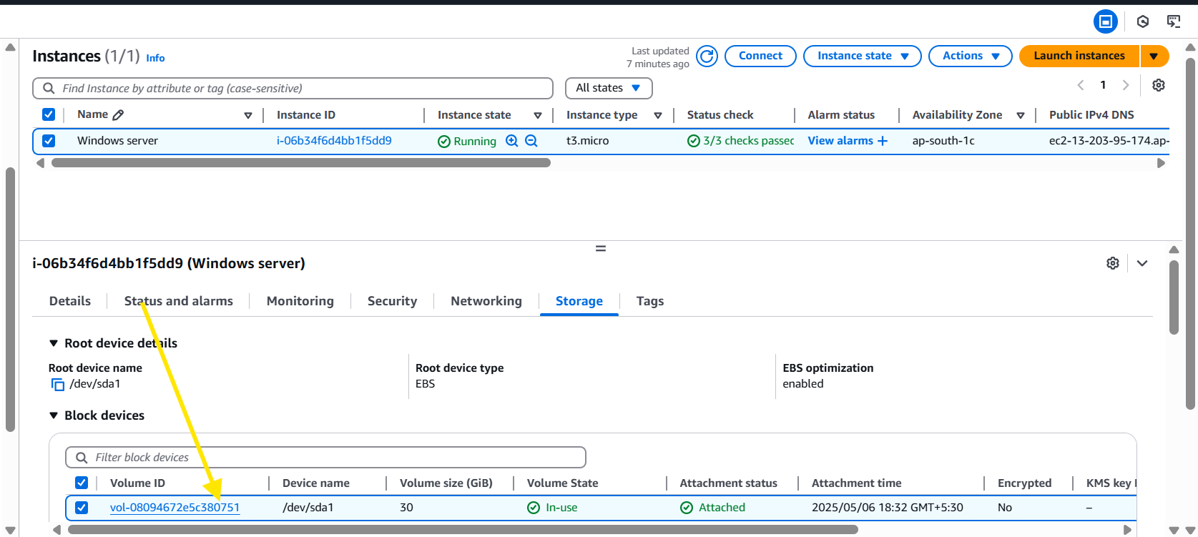
Step 3: you will be navigated to EBS , Click on EBS volume > actions > create snapshot.
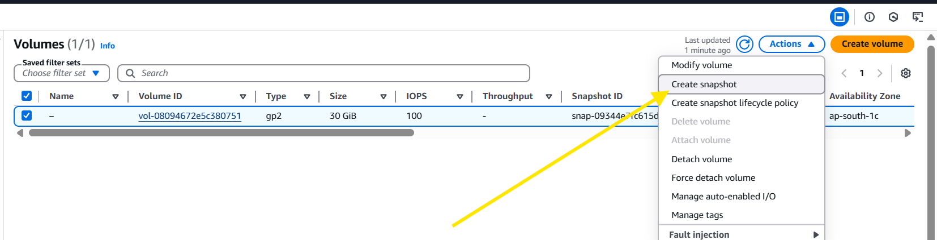
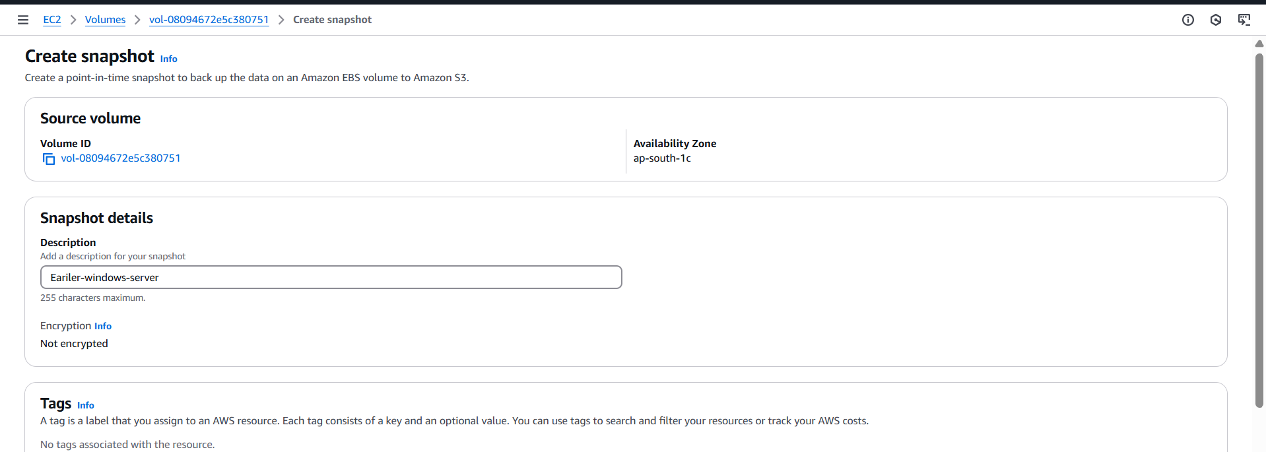
Step 4: under snapshots, we can see the snapshot created.
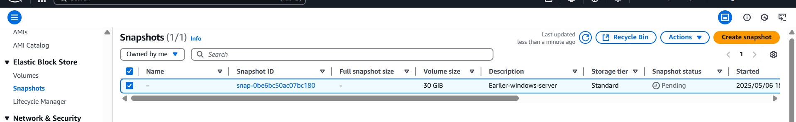
Step 5: Actions > create a Volume from snapshot.
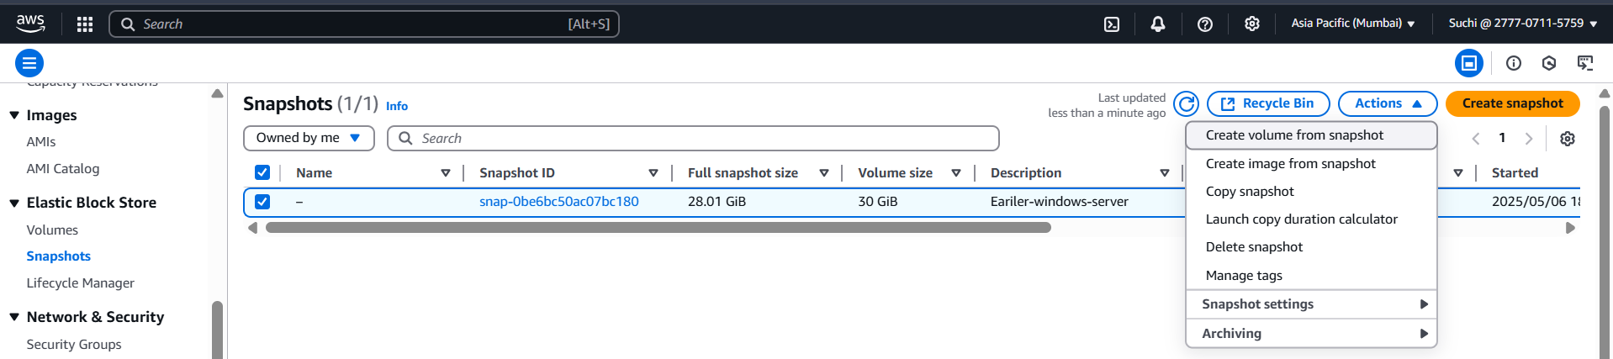
Step 6: If you want the volume to be created in the same region, click on ap-south-1c
But if you want the volume to be created in another AZ means select the AZ. (as of now I will select same region)
And enable encryption if you want (its recommended to enable).
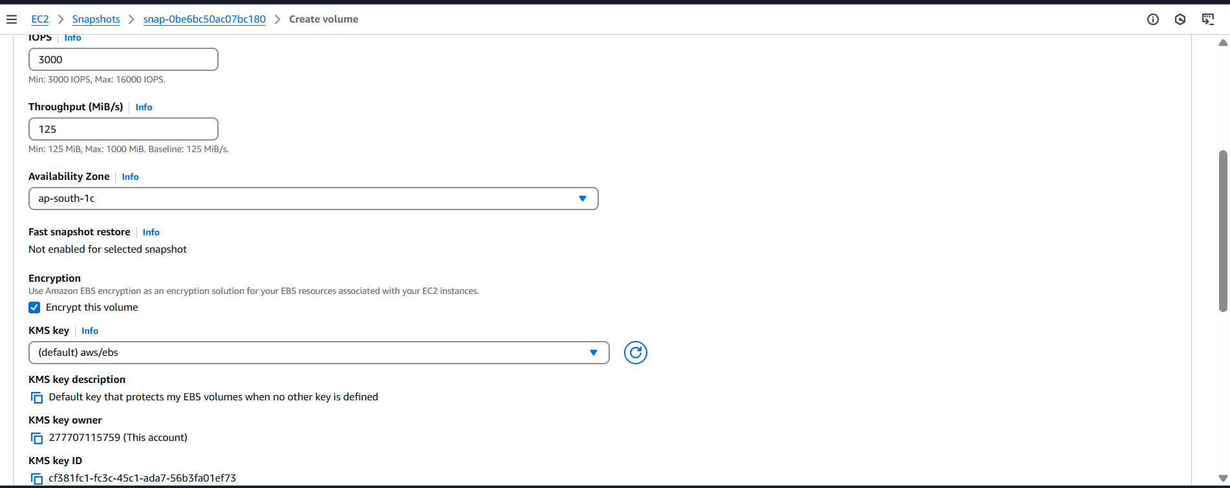
Step 7: validate under volumes, you should be able to view the volume.
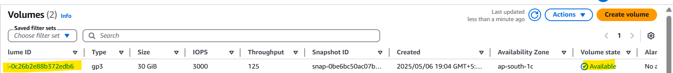
Note: IOPS, can be specified while creating a volume.
Earlier EBS volume had an IOPS of 100 and I have edited it to that 3000 for max input and output.
Scenario: you have a request to increase an IOPS of the storage, you can use this method.
Steps - to turn off the current windows server and detach the earlier volume and attach this newly created volume of 3000 IOPS
Step 8: Lets create a new windows server
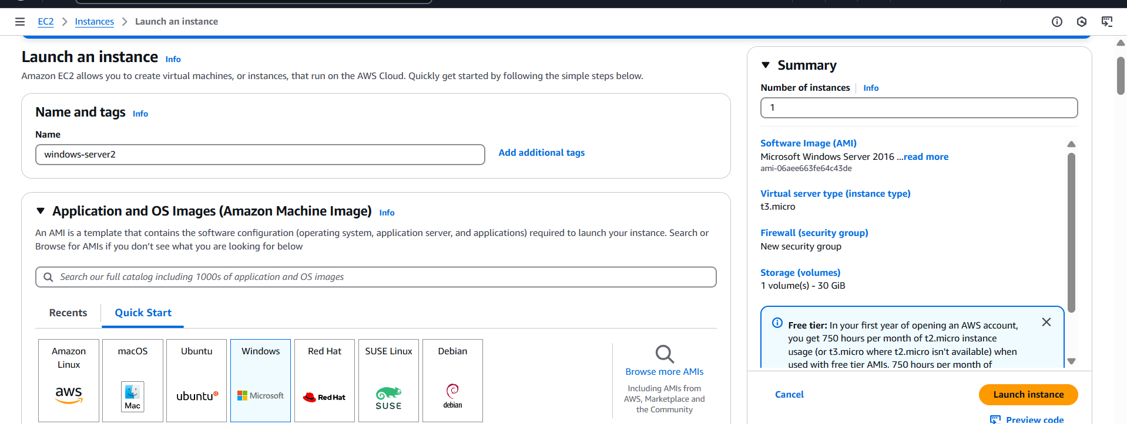
Step 9: once launched turn off the server.
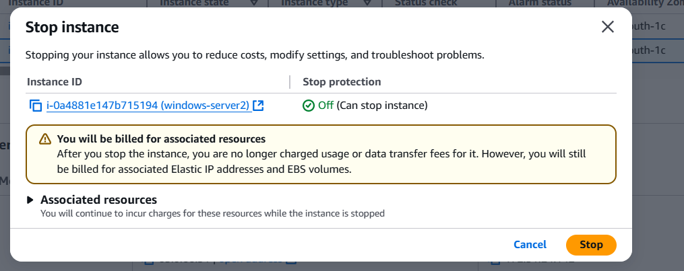
Step 10: go to the volume id of the newly created instance and select detach and attach the earlier volume which we created from snapshot.

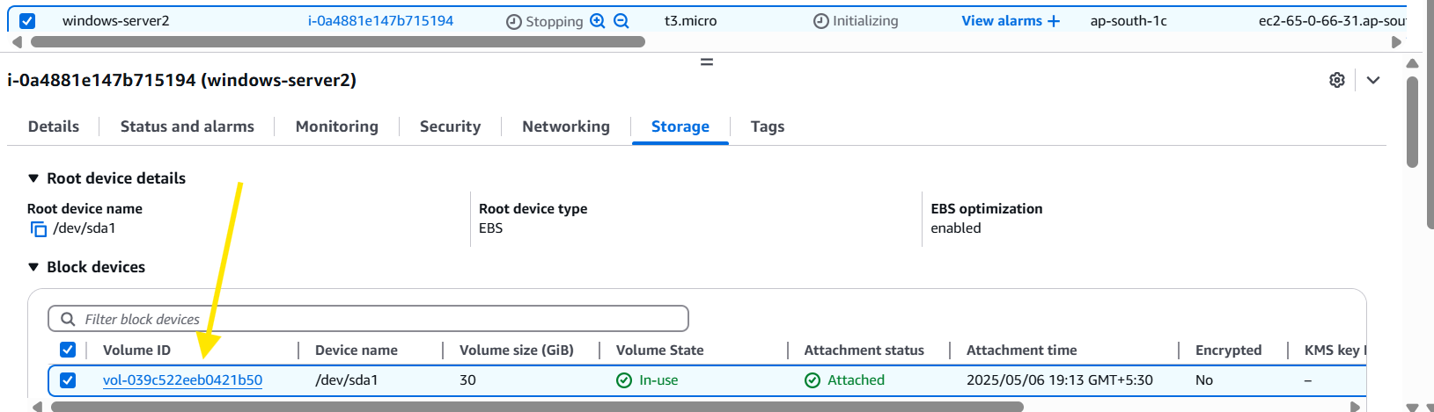
Action > detach the volume
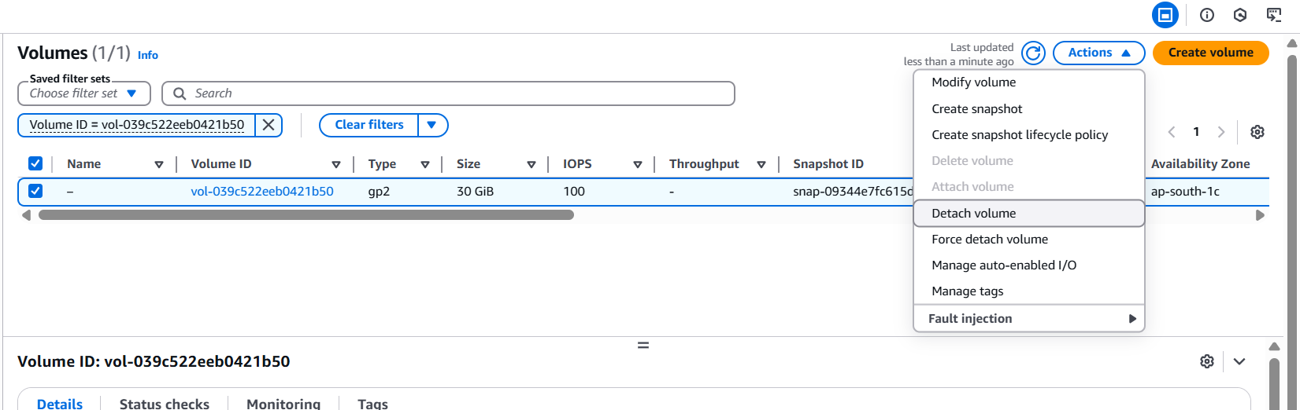
Once done select the volume which we created from snapshot with 3000 IOPS and attach it to an windows-server2.
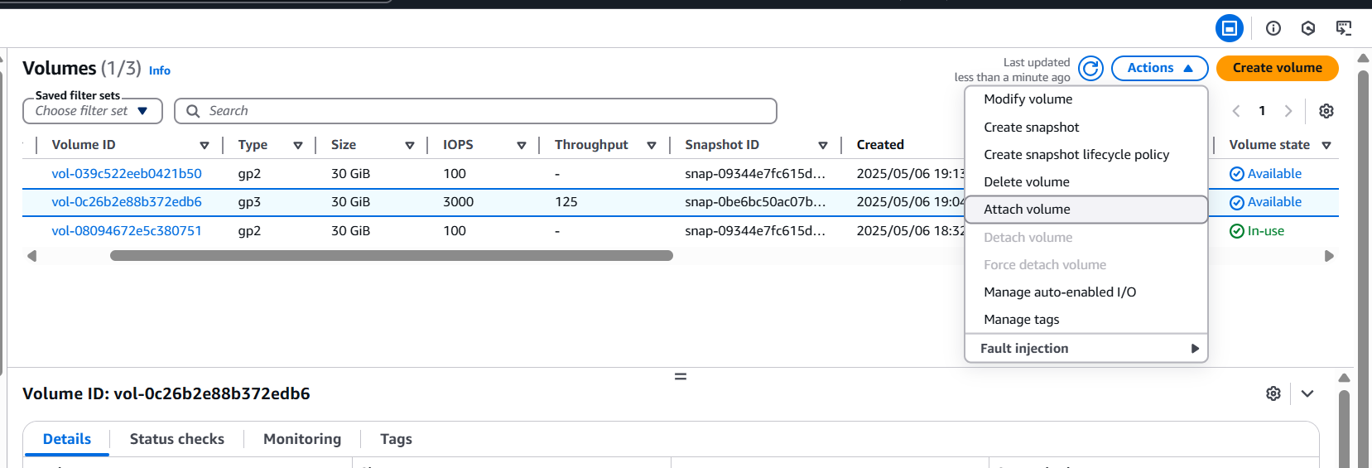
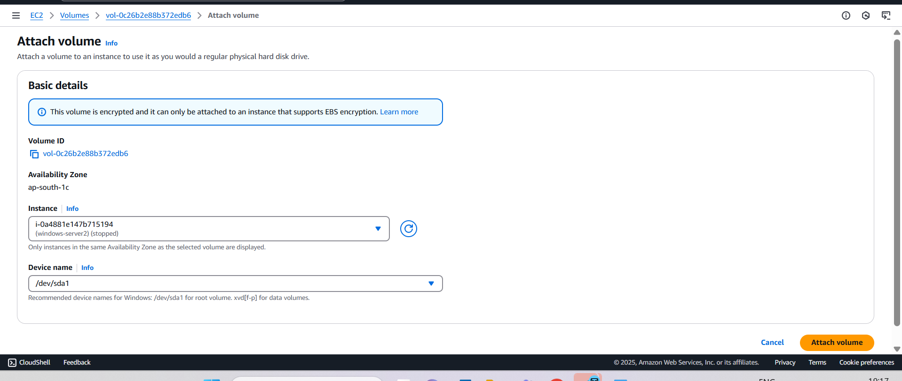

Step 11: once done, turn on the server and validate the files.

